- Data Collection
Raw sensor data is recorded on the Raspberry Pi 5 at 10 Hz and saved as a JSON session file, alongside a synchronised AVI video recorded at 30 fps. Two files are sessions/ session_20260314_123947.json and session_20260314_123947.avi Each JSON frame contains:
{
"session_id": "20260314_123947",
"participant": "Hongpeng Fu",
"start_time": "2026-03-14T12:39:47",
"sample_rate_hz": 10,
"frames": [
{
"timestamp": 1773508700.1096,
"fsr": {
"left": 1,
"right": 235
},
"tof": {
"left_mm": 24,
"right_mm": 83
},
"imu_left": {
"ax": -0.9673,
"ay": 0.1234,
"az": 0.0512,
"gx": -3.4046,
"gy": 1.2345,
"gz": -0.5678
},
"imu_right": {
"ax": -0.7627,
"ay": 0.0987,
"az": 0.0345,
"gx": 1.0305,
"gy": 0.8765,
"gz": -1.2345
}
}
],
"end_time": "2026-03-14T12:45:00",
"total_frames": 3000,
"camera_frame_timestamps": [1773508700.1, 1773508700.13, ...]
}
- Feature Extraction
The JSON session file is processed offline to produce two CSV outputs.

frames.csv — Per-frame derived signals
Column | Source | Description
t | JSON | Unix timestamp
fsr_l, fsr_r | FSR | Raw pressure ADC values (0–1023)
tof_l, tof_r | ToF | Shin distance (mm); 8190 = out of range
imu_l_ax/ay/az | IMU left | Accelerometer (g)
imu_l_gx/gy/gz | IMU left | Gyroscope (°/s)
imu_r_ax/ay/az | IMU right | Accelerometer (g)
imu_r_gx/gy/gz | IMU right | Gyroscope (°/s)
lift_angle_l/r | IMU | Shin elevation angle via complementary filter (°)
omega_l/r | IMU | Angular velocity magnitude √(gx²+gy²+gz²) (°/s)
jerk_l/r | IMU | Rate of change of acceleration magnitude (g/s)
tof_vel_l/r | ToF | Shin velocity via gradient (mm/s)
frame_label | System | Phase label: rest / lift_left / hold / lower_right
knee_angle | Camera optional | Knee extension angle from YOLOv8-pose (°)
shin_angle_vertical | Camera optional | Shin angle vs vertical from YOLOv8-pose (°)
trunk_lean | Camera optional | Trunk forward/backward lean (°)
ankle_disp_px | Camera optional | Ankle vertical displacement from baseline (px)
near_visibility | Camera optional | YOLOv8 keypoint confidence score

reps.csv — Per-repetition metrics
Column | Source | Description
session_id | System | Session identifier
rep_id | System | Repetition number within session
leg | ToF L/R | Left or right leg
duration_s | ToF | Total rep duration: rest→lift→hold→lower→rest (s)
lift_duration_s | ToF + IMU | Time from onset to peak distance (s)
hold_duration_s | ToF + IMU | Time at peak with ω < 5°/s (s)
lower_duration_s | ToF + IMU | Time from peak back to rest (s)
peak_tof_mm | ToF | Maximum shin distance during rep (mm)
shin_lift_angle_deg | IMU | Peak shin elevation angle (°)
peak_angular_velocity | IMU | Maximum angular velocity during rep (°/s)
jerk_score | IMU | Mean absolute jerk — lower = smoother (g/s)
tof_symmetry | ToF L/R | Left-right peak distance asymmetry (0=symmetric, 1=asymmetric)
flagged | System | True if any flag is triggered
flag_hold | hold_duration_s | Hold duration < 0.1 s
flag_angle | shin_lift_angle_deg | Lift angle < 20°
flag_jerk | jerk_score | Jerk above 90th session percentile

- Output Summary and current dashboard
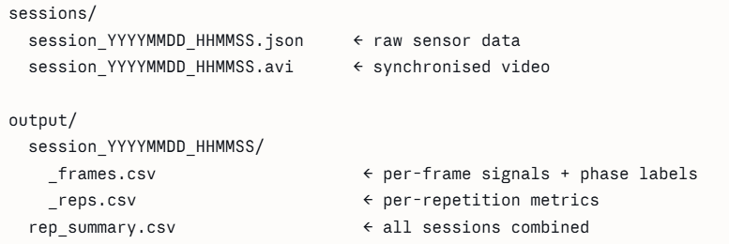
Seated Knee Extension Attributes (But may change accordingly during the trial stage)
Attribute | Source | Description
rep_id | System | Repetition number
leg | ToF L/R | Left or right leg
duration_s | ToF | Total rep duration (s)
lift_duration_s | ToF + IMU | Time from onset to peak (s)
hold_duration_s | ToF + IMU | Time stationary at peak (s)
lower_duration_s | ToF + IMU | Time from peak back to rest (s)
shin_lift_angle_deg | IMU shin | Peak shin elevation angle (°)
peak_angular_velocity | IMU shin | Maximum angular velocity (°/s)
jerk_score | IMU shin | Movement smoothness — lower is smoother (g/s)
fsr_unload | FSR L/R | Thigh unloading magnitude during lift
tof_symmetry | ToF L/R | Left-right lift symmetry (0=perfect, 1=fully asymmetric)
flagged | System | Rep flagged for review
flag_hold | hold_duration_s | Hold duration < 0.1s
flag_angle | shin_lift_angle_deg | Lift angle < 20°
flag_jerk | jerk_score | Jerk above 90th session percentile

Seated Hip Flexion Attributes (But may change accordingly during the trial stage)
Attribute | Source | Description
rep_id | System | Repetition number
leg | ToF + FSR | Left or right leg
duration_s | ToF | Total rep duration (s)
lift_duration_s | ToF + IMU | Time from onset to peak (s)
hold_duration_s | ToF + IMU | Time stationary at peak (s)
lower_duration_s | ToF + IMU | Time from peak back to rest (s)
shin_lift_angle_deg | IMU shin | Whole-leg elevation angle proxy (°)
peak_angular_velocity | IMU shin | Maximum angular velocity (°/s)
jerk_score | IMU shin | Movement smoothness — lower is smoother (g/s)
fsr_unload | FSR L/R | Thigh unloading magnitude during lift
tof_symmetry | ToF L/R | Left-right lift symmetry (0=perfect, 1=fully asymmetric)
flagged | System | Rep flagged for review
flag_hold | hold_duration_s | Hold duration < 0.1s
flag_angle | shin_lift_angle_deg | Lift angle < 20°
flag_jerk | jerk_score | Jerk above 90th session percentile

